* 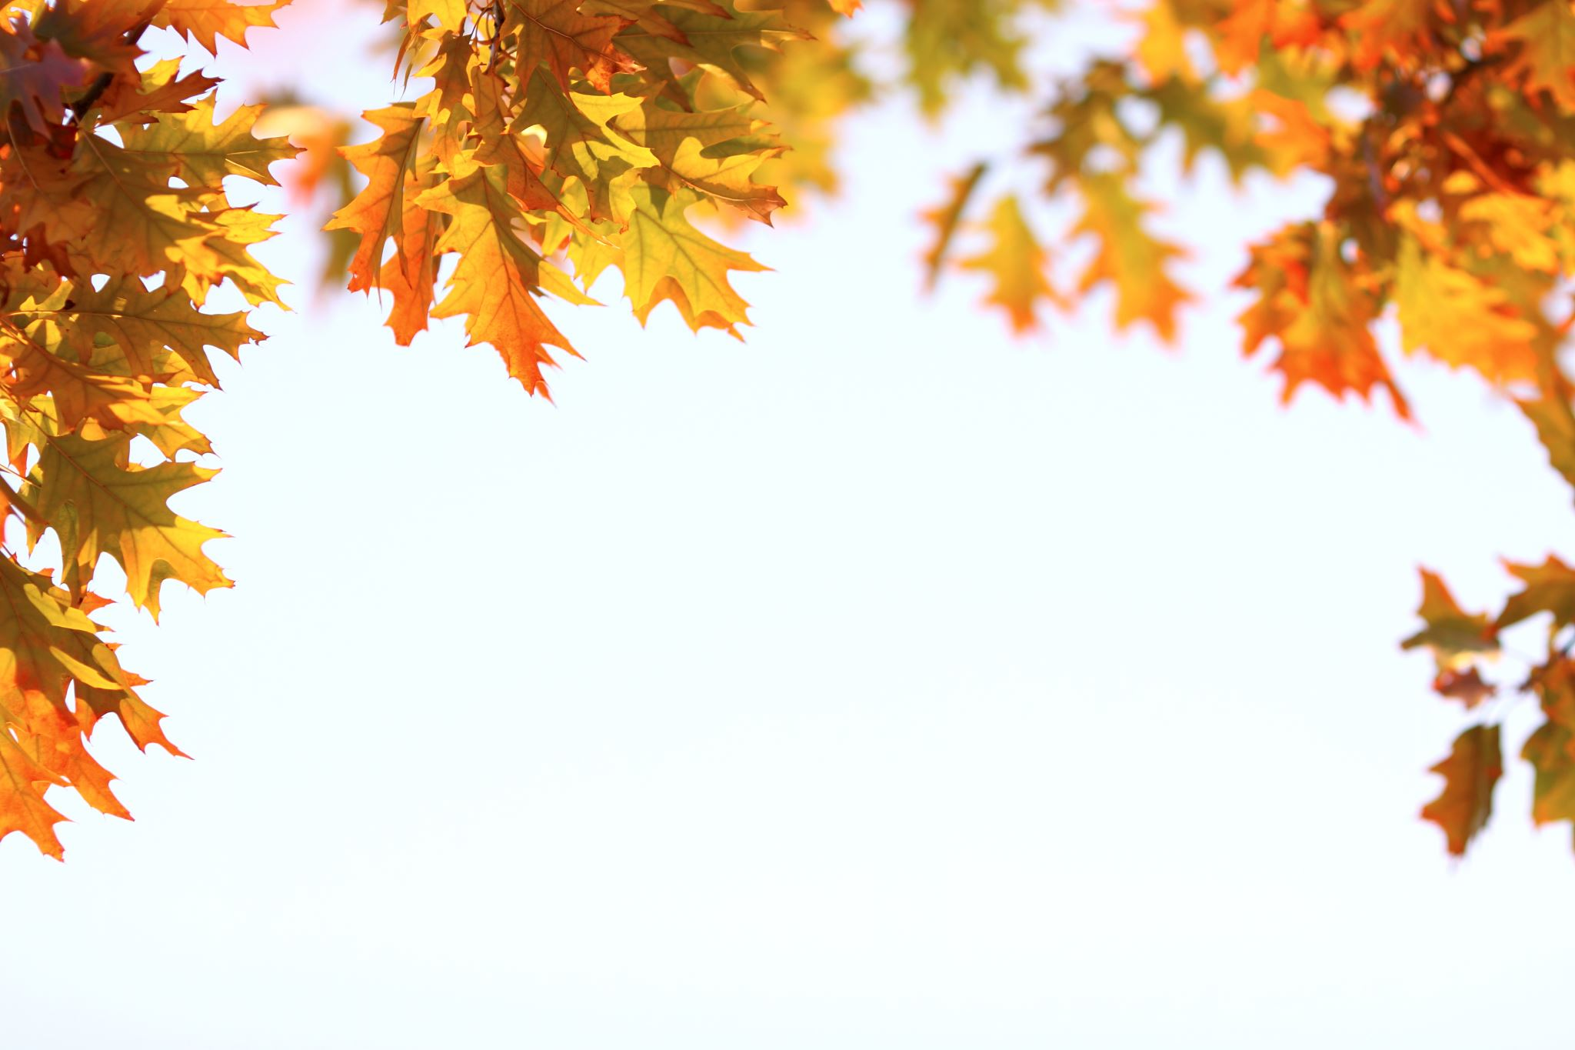   
  **October Snacks at Hackberry**

|  |  |  |  |  |  |  |
| --- | --- | --- | --- | --- | --- | --- |
| SUN | MON | TUE | WED | THU | FRI | SAT |
|  |  | 1  Popcorn and Fruit | 2  String Cheese, Pretzels and Carrots | 3  Veggie Straws, Hummus and Veggies | 4  Raid the Fridge | 5 |
| 6 | 7  Tortilla Chips with Salsa and Veggies | 8  Cereal with Milk and Bananas | 9  Bagels with Cream Cheese and Dried Fruit | 10  Veggie Straws with Cuties | 11  Raid the Fridge | 12 |
| 13 | 14  Cheez-its and Applesauce | 15  Crackers with Cheese and Veggies | 16  Turkey and Cheese Roll Ups with Carrots | 17  Full Day @Semper | 18  Full Day @Semper | 19 |
| 20 | 21  Muffins and Fruit Cups | 22  Granola Bars and Dried Fruit | 23  Animal Crackers with Yogurt and Berries | 24  Fruit and Veggie Straws | 25  Raid the Fridge | 26 |
| 27 | 28  Graham Crackers and Yogurt w/ Fruit | 29  Cereal Bars and Fruit | 30  Goldfish and Carrots | 31 |  |  |

|  |  |  |  |  |  |
| --- | --- | --- | --- | --- | --- |
| Site Manager:  Alyssa Brown 303.519.3745  [Alyssa.Brown@rrcc.edu](mailto:Alyssa.Brown@rrcc.edu) | Program Manager  Allie Jones  Allie.Jones@rrcc.edu  Program Director  Sarah Espinoza  Sarah.Espinoza  @rrcc.edu | SACC Office Info  sacc@rrcc.edu  Hours:  6:30-7:45am &  2:35-6:00pm | All snacks are served with Milk and Water | 2:35 CHOICES (Check in, Homework, Outside, Inside, Centers, Engineer, Snack)  3:30 STEAM or Gym | 4:30 Study Hall Box, Read Aloud, Study Hall Activity, Homework  5:15 Clean up and Centers |



October Activities at Hackberry

|  |  |  |  |  |
| --- | --- | --- | --- | --- |
| MON | TUE | WED | THU | FRI |
| STEAM: Build Your Own Cubby  GYM:  SH: Bluey Charades | 1  STEAM: Weave Your Own Flappy  GYM:  SH: Barky Boats Book Chart | 2  STEAM: Tourist Camera  GYM:  SH: Bluey Word Searches | 3  STEAM: Bluey Marionette  GYM:  SH: Bandit’s Letters | 4  STEAM: Gnome Toast  GYM:  SH: Learn How to Draw Bluey and Friends |
| 7  STEAM: School Safe Elephant Toothpaste  GYM:  SH: James Bond | 8  STEAM: Crayon Lava Lamp  GYM:  SH: Solitaire | 9  STEAM: Drip Drop Bottle  GYM:  SH: Spit | 10  STEAM: What Color is Black?  GYM:  SH: Tri Peaks Solitaire | 11  STEAM: Magic Painting  GYM:  SH: Speed |
| 14  STEAM: Anit-Brown Apple Experiment  GYM:  SH: Longest Paper Chain | 15  STEAM: Leaf Pounding  GYM:  SH: DA Vinci Pencil Bridge | 16  STEAM: Fractal Leaf Art  GYM:  SH: DIY Sundial | 17  Full Day @Semper | 18  Full Day @Semper |
| 21  STEAM: Fizzing Pumpkin  GYM:  SH: Color by Addition | 22  STEAM: Dissolving Pumpkin Candies  GYM:  SH: DIY Math Board Game | 23  STEAM: Anatomy of a Pumpkin  GYM:  SH: Space Facts | 24  STEAM: Disappearing Pumpkin Art  GYM:  SH: Binary Code | 25  STEAM: Mixed Media Pumpkin  GYM:  SH: Index Card Building Challenge |
| 28  STEAM: Pony Bead Pumpkin  GYM:  SH: Squiggle Art | 29  STEAM: Halloween Pointillism  GYM: SH: Origami Spider Web | 30  STEAM: Build a Spider Web  GYM: SH: DIY Jack o’ lantern Memory Game | 31  STEAM: Neon Lights Pumpkin  GYM: SH: Positive/Negative Space Jack o ’lantern |  |

|  |  |  |  |  |  |
| --- | --- | --- | --- | --- | --- |
| Site Manager:  Alyssa Brown  303.519.3745  Alyssa.Brown@rrcc.edu | Program Manager  Allie Jones  Allie.Jones@rrcc.edu  Program Director  Sarah Espinoza  Sarah.Espinoza@ rrcc.edu | SACC Office Info  sacc@rrcc.edu  Hours:  6:30-7:45am &  2:35-6:00pm  All snacks are served with Milk and Water |  | 2:35 CHOICES (Check in, Homework, Outside, Inside, Centers, Engineer, Snack)  3:30 STEAM or Gym | 4:30 Study Hall Box, Read Aloud, Study Hall Activity, Homework  5:15 Clean up and Centers |