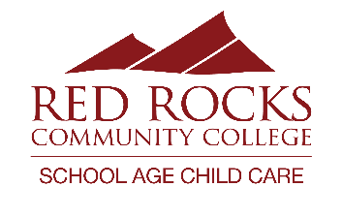
2024-2025 Schedule and Tuition
Kendrick Lakes Elementary
303-519-3735
Visit our website for more information! https://www.rrcc.edu/school-age-childcare
Main Office: 303-914-6203; sacc@rrcc.edu
TUITION:

Registration Fee (non-refundable):
- Summer 2024: $70.00 per child
- 24-25 School Year: $60.00 for one child / $95.00 per family

Daily Option Rates:
- AM Only: $10.60
- PM Only: $24.60
- AM & PM: $28.30

Variable Option Rates:
- AM only: $12.60
- PM only: $26.60
- AM & PM: $30.30

Modified Contact Day Rates:
- Full Day: $46.50
- Full Day with Field Trip: $53.50

Drop-In Rates: additional $5.00 per session
DISCOUNTS:
10% Discount:
- Family discount (Oldest child)
- RRCC Employees
- Active Military
- 1st Responder
- Jeffco School District Employee Discount

20% Discount: Free/Reduced Lunch Discount – excluding Drop In care

We accept families in the Colorado Child Care Assistance Program (CCCAP) at all schools except Maple Grove and Mitchell.

Proof of discount qualification can be emailed to sacc@rrcc.edu.
PROGRAM TIMES:
School Days: 6:30am – 7:45am and 2:35pm – 6:00pm
Full days of care: 6:30am – 6:00pm

SCHEDULE:

Summer Camp: May 30th – August 9th
August 10th – 14th: Closed for Staff Training and School Year Preparation
August 15th: 1st day of care for School Year
September 2nd: Closed for Labor Day
September 20th: Full Day of care
October 17th and 18th: Fall Break Care
November 25th – 27th: Thanksgiving Break Care
November 28th and 29th: Closed for Thanksgiving
December 23rd and 24th - Winter Break Care
December 25th – January 1st: Closed for holidays

January 2nd-6th: Winter Break Care
January 20th: Closed for MLK day
February 14th: Full Day of Care
February 17th: Closed for President’s Day
March 17th – 24th: Spring Break Care
April 25th: Full Day of Care
May 22nd: Last day of care offered for the 24-25 SY
May 27th – May 28th: RRCC Closed for Staff Training and Summer Preparation

Full days of care will be at designated programs. Check your monthly newsletter for details.

