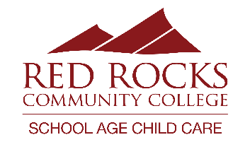
2024-2025 Schedule and Tuition
Bear Creek K-8
303-519-6377
Visit our website for more information! https://www.rrcc.edu/school-age-childcare
Main Office: 303-914-6203; sacc@rrcc.edu
TUITION:

Registration Fee (non-refundable):
- Summer 2023: $70.00 per child
- 23-24 School Year: $60.00 for one child / $95.00 per family

Daily Option Rates:
- AM Only: $18.20
- PM Only: $18.20
- AM & PM: $28.30

Variable Option Rates:
- AM only: $20.20
- PM only: $20.20
- AM & PM: $30.30

Modified Contact Day Rates:
- Full Day: $46.50
- Full Day with Field Trip: $53.50

Drop-In Rates: additional $5.00 per session
DISCOUNTS:
10% Discount:
- Family discount (Oldest child)
- RRCC Employees
- Active Military
- 1st Responder
- Jeffco School District Employee Discount

20% Discount: Free/Reduced Lunch Discount – excluding Drop-In care

We accept families in the Colorado Child Care Assistance Program (CCCAP)

Proof of discount qualification can be emailed to sacc@rrcc.edu.
PROGRAM TIMES:
School Days: 6:30am – 8:40am and 3:50pm – 6:00pm
Full days of care: 6:30am – 6:00pm

SCHEDULE:

Summer Camp: May 30th – August 9th
August 10th – 14th: Closed for Staff Training and School Year Preparation
August 15th: 1st day of care for School Year
September 2nd: Closed for Labor Day
September 20th: Full Day of care
October 17th and 18th: Fall Break Care
November 25th – 27th: Thanksgiving Break Care
November 28th and 29th: Closed for Thanksgiving
December 23rd and 24th - Winter Break Care
December 25th – January 1st: Closed for holidays

January 2nd-6th: Winter Break Care
January 20th: Closed for MLK day
February 14th: Full Day of Care
February 17th: Closed for President’s Day
March 17th – 24th: Spring Break Care
April 25th: Full Day of Care
May 22nd: Last day of care offered for the 24-25 SY
May 27th – May 28th: RRCC Closed for Staff Training and Summer Preparation

Full days of care will be at designated programs. Check your monthly newsletter for details.

