How to Schedule an Appointment in the RRCC Writing Center

- Go to the Red Rocks home page at https://www.rrcc.edu/, and click on the “A-Z” tab at the top of the page.

- At the top of the next page, click on “W.”
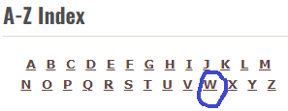

- Under the “W” listings, click on “Writing Center.”
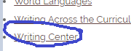

- On the Writing Center webpage, click on the button for “Schedule an Appointment Here.”
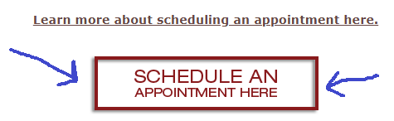

- The next screen will prompt you to sign into The Rock portal.
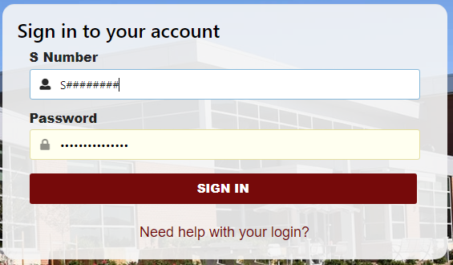

- If you’ve never visited the Writing Center before, you’ll be prompted on the next screen to set up your account.
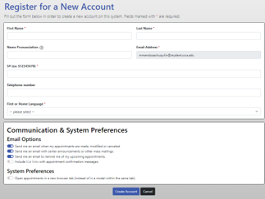

- At the top of the next page, click on the “Schedules” tab, and select from the 3 tutoring options.
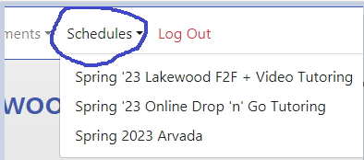

- Choose your desired appointment time by clicking on a white box. (Blue, gray & black boxes are not available.) Appointments begin every hour and half-hour and last 30 minutes. Your scheduled appointment will show as a yellow box.
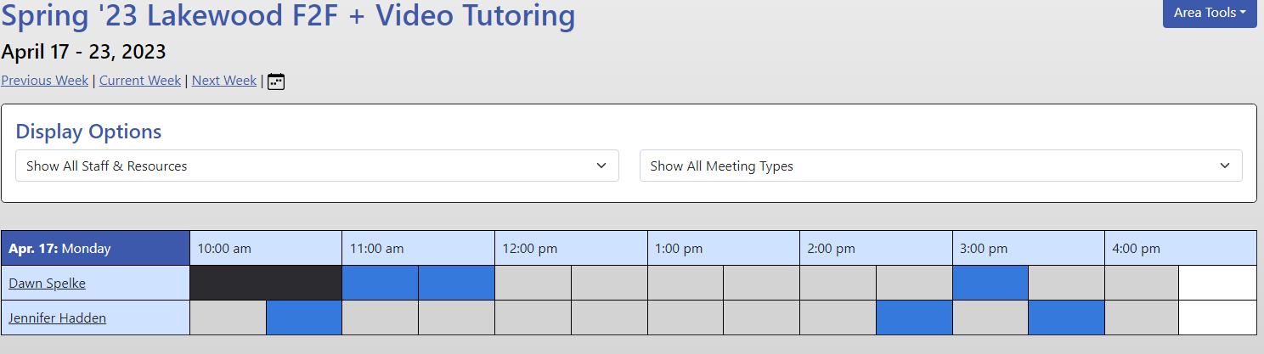

- If you chose Lakewood F2F + Video Tutoring, look under “Meet Online?” on the following page, and click “No” if you want a face-to-face appointment, or click “Yes” if you want a video appointment. To access your video appointment, follow steps 1-5 & 7, and click on the box in your appointment time.
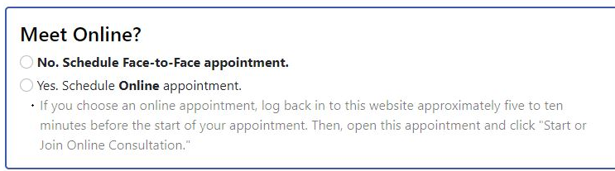

- If you chose Online Drop ‘n Go Tutoring, look under “File Attachments” on the following page, and upload the assignment instructions and a draft of your paper. You’ll receive written feedback in 36 hours or less. Check your RRCC student email in The Rock portal for a notification that your feedback is ready.
